Artigos: Covid na Base Scopus:
Levantamento realizado em 07/04/2021
Instituições: Ufes é a 24 em maior quantidade de artigos entre as instituições brasileiras com 39 artigos
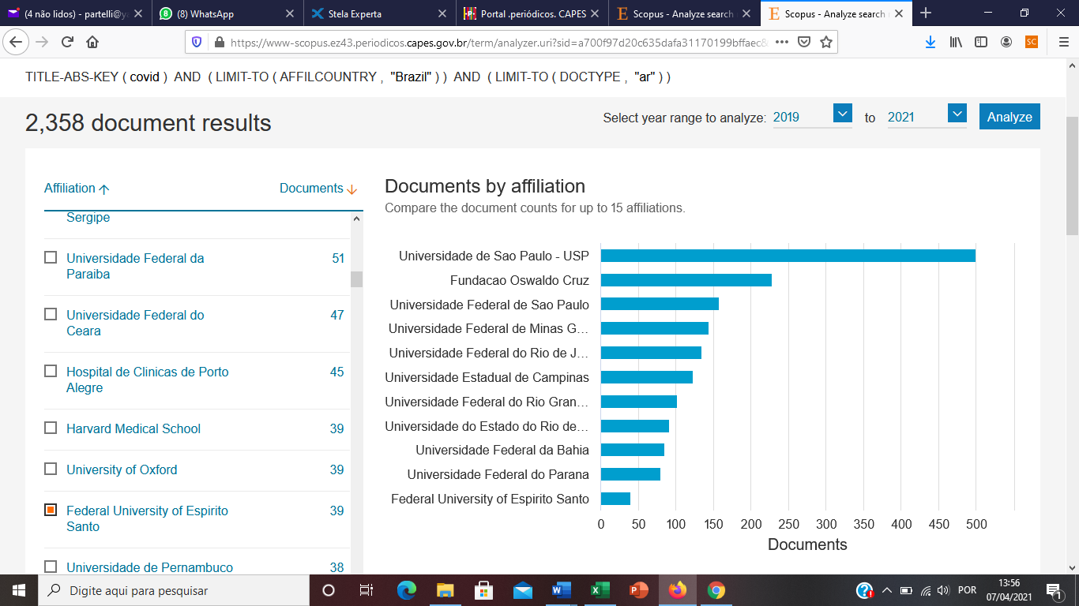

Títulos dos artigos:
1. | Reduced level of physical activity during COVID-19 pandemic is associated with depression and anxiety levels: an internet-based survey
2. | Comparisons between the neighboring states of amazonas and pará in brazil in the second wave of covid-19 outbreak and a possible role of early ambulatory treatment
3. | Emergency 3-Dimensional-Printed Devices for Splitting Ventilators in Lungs With Different Compliances: An In Vitro Study
4. | The COVID-19 pandemic, emergency aid and social work in Brazil
5. | Ultrarapid On-Site Detection of SARS-CoV-2 Infection Using Simple ATR-FTIR Spectroscopy and an Analysis Algorithm: High Sensitivity and Specificity
6. | Collision of Fundamental Human Rights and the Right to Health Access During the Novel Coronavirus Pandemic
7. | Impact of concurrent epidemics of dengue, chikungunya, zika, and covid-19
8. | Factors associated with Brazilian physical therapists’ perception of stress during the COVID-19 pandemic: a cross-sectional survey
9. | The use of health geography modeling to understand early dispersion of COVID-19 in São Paulo, Brazil
10. | Physical activity levels and mental health during the covid-19 pandemic: Preliminary results of a comparative study between convenience samples from brazil and switzerland
11. | Brazilian housemaids and COVID-19: How can they isolate if domestic work stems from racism?
12. | Sinus computed tomography findings in patients with COVID-19
13. | Covert cases of severe acute respiratory syndrome coronavirus 2: An obscure but present danger in regions endemic for Dengue and Chikungunya viruses
14. | COVID-19 and Brazilian handball coaches: Impacts on training prescription and professional learning
15. | Global citizenship education (GCE) in internationalisation: COIL as alternative Thirdspace
16. | Helping Couples Connect during the COVID-19 Pandemic: A Pilot Randomised Controlled Trial of an Awareness, Courage, and Love Intervention
17. | Hydroxychloroquine Exhibits a Strong Complex Interaction with DNA: Unraveling the Mechanism of Action
18. | Physical activity and sociodemographic profile of brazilian people during COVID-19 outbreak: An online and cross-sectional survey
19. | Brazilian Consortium for the Study on Renal Diseases Associated With COVID-19: A Multicentric Effort to Understand SARS-CoV-2-Related Nephropathy
20. | Ethnic and regional variations in hospital mortality from COVID-19 in Brazil: a cross-sectional observational study
21. | Relationship between COVID-19 and weather: Case study in a tropical country
22. | Guidelines for TMS/tES clinical services and research through the COVID-19 pandemic
23. | Early childhood education, government policies and mobilizations in times of pandemic | [Educação Infantil, políticas governamentais e mobilizações em tempos de pandemia]
24. | Pandemic responses in vulnerable communities: A simulationoriented approach | [Respostas à pandemia em comunidades vulneráveis: Uma abordagem de simulação]
25. | O raciocinio geografico e as chaves de leitura da Covid-19 no territorio brasileiro
26. | Is it time to talk about the end of social distancing? A joinpoint analysis of COVID-19 time series in Brazilian capitals
27. | Two hundred days of COVID-19 in São Paulo State, Brazil
28. | Brazilian Nursing Process Research Network contributions for assistance in the COVID-19 pandemic
29. | Increasing molecular diagnostic capacity and COVID-19 incidence in Brazil
30. | Severe coronavirus infection in pregnancy: Challenging cases report
31. | Effectiveness of auriculoacupuncture on the sleep quality of working nursing professionals during the COVID-19 pandemic | [Efetividade da auriculoacupuntura na qualidade do sono de profissionais de enfermagem atuantes na COVID-19]
32. | The Pandemic and its Ethno-Spatial Disparities: Considerations from Salvador, Bahia, Brazil
33. | “Brazil cannot stop”: Meritocratic ideology in an unequal country
34. | Overview on the recommendations for breastfeeding and COVID-19
35. | COVID-19: Reflections on the Crisis, Transformation, and Interactive Processes Under Development
36. | Intervention strategies in the Care Routine at the Human Milk Bank in the face of the COVID-19 pandemic
37. | Searching for potential drugs against SARS-CoV-2 through virtual screening on several molecular targets
38. | The increase in domestic violence during the social isolation: What does it reveals? | [Isolamento social e o aumento da violência doméstica: O que isso nos revela?]
39. | Genomic and phylogenetic characterisation of an imported case of sars-cov-2 in amazonas state, brazil

Segue os artigos mais citados:
1. Ethnic and regional variations in hospital mortality from COVID-19 in Brazil: a cross-sectional observational study. Open Access. Baqui, P., Bica, I., Marra, V., Ercole, A., van der Schaar, M. 2020. The Lancet Global Health 8(8), pp. e1018-e1026 80 citações
2. Relationship between COVID-19 and weather: Case study in a tropical country. Open Access. Rosario, D.K.A., Mutz, Y.S., Bernardes, P.C., Conte-Junior, C.A. 2020. International Journal of Hygiene and Environmental Health. 229,113587. 24 citações.
3. Guidelines for TMS/tES clinical services and research through the COVID-19 pandemic. Open Access. Bikson, M., Hanlon, C.A., Woods, A.J., (...), Zhang, X., Ekhtiari, H. 2020 Brain Stimulation. 13(4), pp. 1124-1149. 23 citações.
4. The increase in domestic violence during the social isolation: What does it reveals? | [Isolamento social e o aumento da violência doméstica: O que isso nos revela?]. Open Access. Vieira, P.R., Garcia, L.P., Maciel, E.L.N. 2020. Revista Brasileira de Epidemiologia. 23, E200033. 15 citações.

